SCATTER GRAPHS
Pearson Edexcel - Thursday 8 November 2018 - Paper 2 (Calculator) Foundation Tier

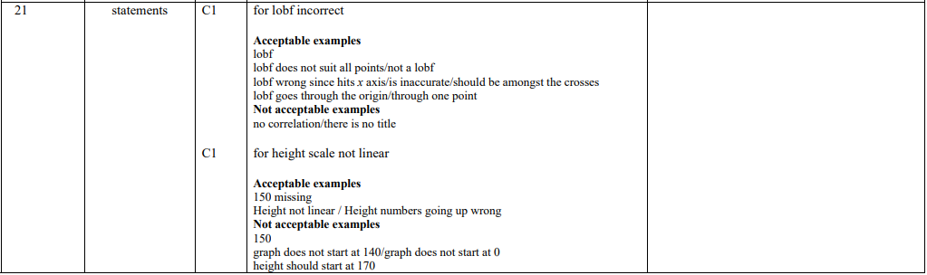

Pearson Edexcel - Tuesday 12 June 2018 - Paper 3 (Calculator) Foundation Tier

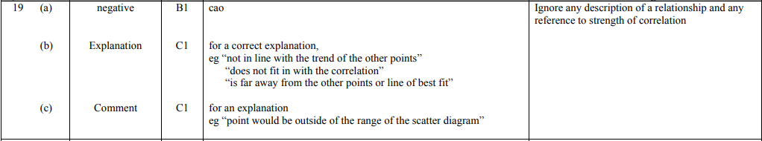

Pearson Edexcel – Specimen 2 - Paper 3 (Calculator) Foundation Tier

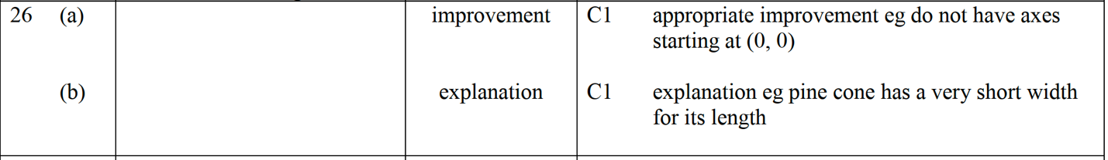

Pearson Edexcel – Specimen 1 - Paper 3 (Calculator) Foundation Tier

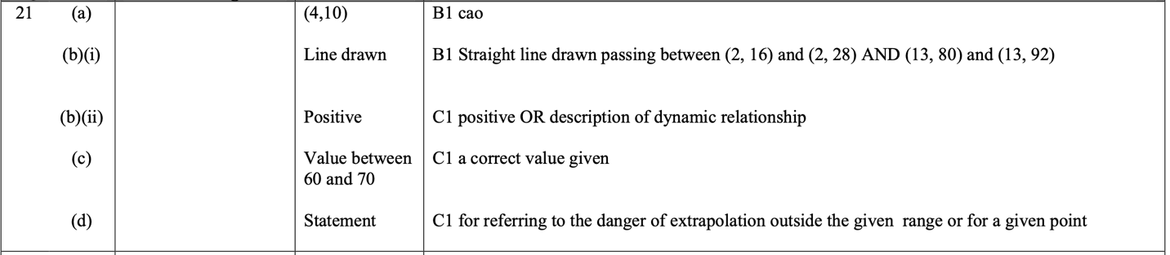
OCR November 09 November 2020- Morning (Calculator) Foundation Tier

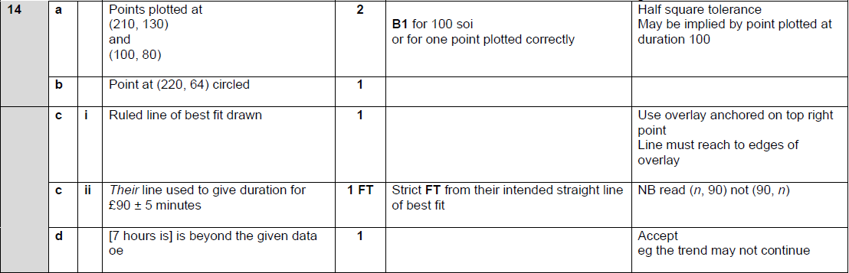

OCR Tuesday 5 November 2019 – Morning (Calculator) Foundation Tier
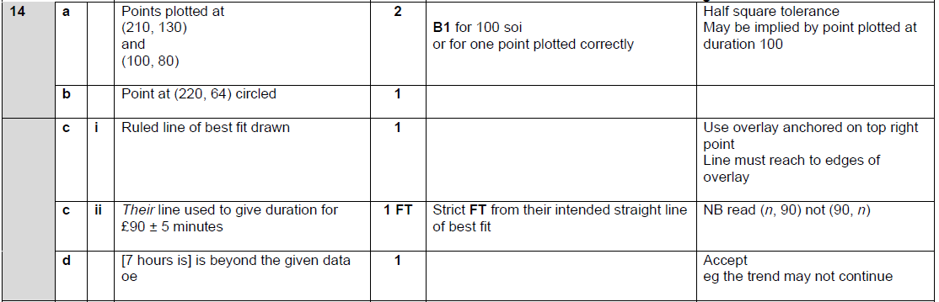

OCR Thursday 6 June 2019 – Morning (Non-Calculator) Foundation Tier
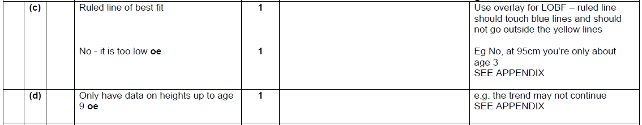
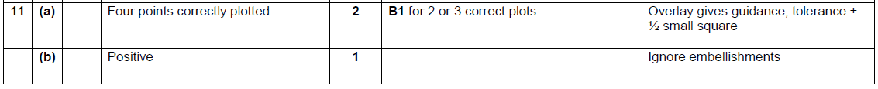

OCR Monday 12 November 2018 – Morning (Calculator) Foundation Tier
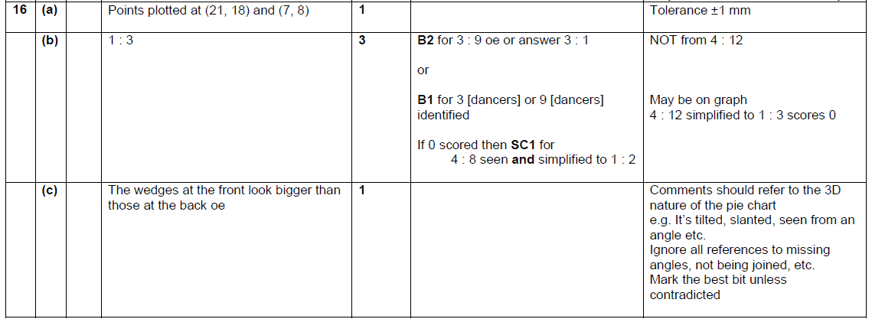

OCR Monday 24 May 2018 – Morning (Calculator) Foundation Tier
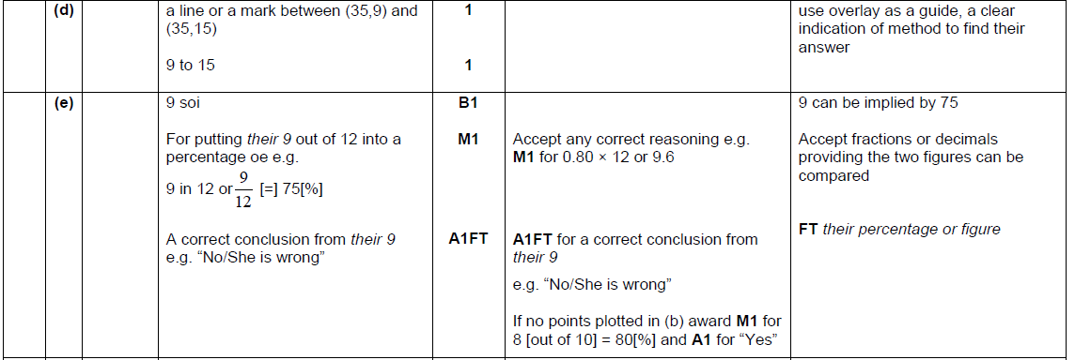
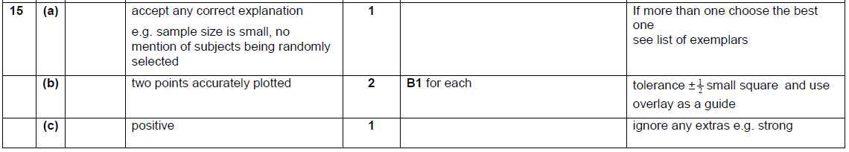

OCR Thursday 2 November 2017– Morning (Calculator) Foundation Tier
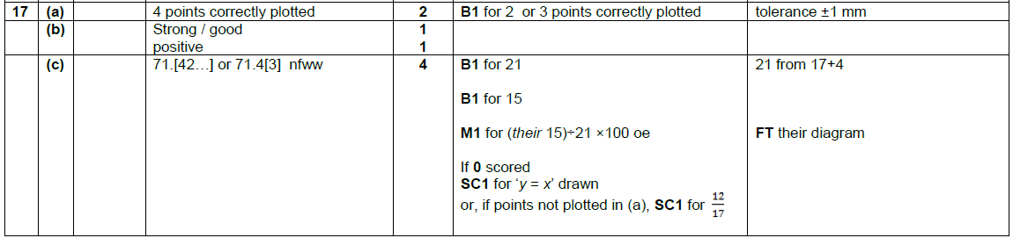

Pearson Edexcel – Sample Papers - Paper 3 (Calculator) Foundation Tier

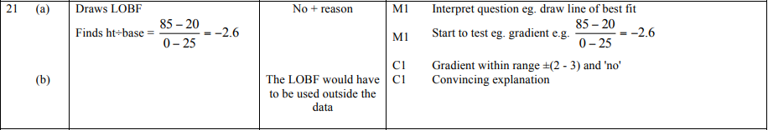
OCR Sample Question Paper 2 – Morning/Afternoon (Non - Calculator) Foundation Tier

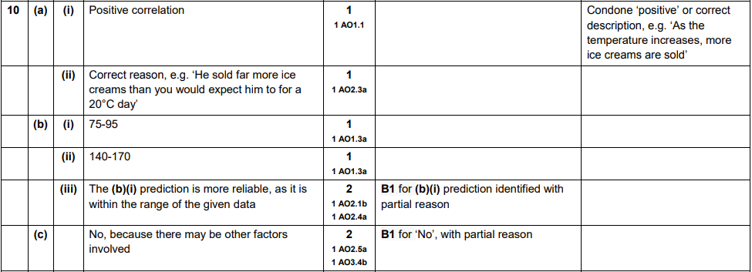

AQA Tuesday 19 May 2020 – Morning (Non-Calculator) Foundation Tier

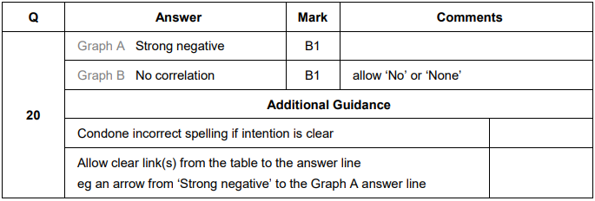
AQA Thursday 7 June 2018 – Morning (Calculator) Foundation Tier

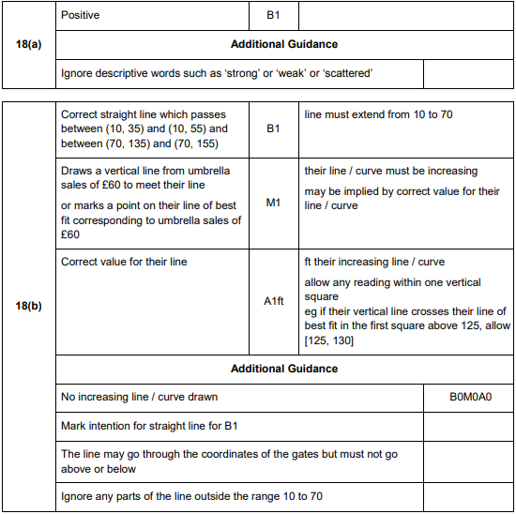

AQA Thursday 8 June 2017– Morning (Calculator) Foundation Tier

